



adges UI components library

**Component ID #1 – ex-icon-card - v1.0.0**

## Document Control

## Version History

|  |  |  |  |
| --- | --- | --- | --- |
| Version | Date | Author | Reason for Change |
| **1.0.0** | 10/10/2019 | Wael |  |
| **1.0.1** | 15/4/2020 | Waqas Khan | New styling Title and detail in list |
| **1.0.2** | 10/4/2020 | Waqas Khan | Card hover effect |
| **1.0.3** | 09/4/2020 | Waqas Khan | List item with number and detail |
| **1.1.0** | 09/23/2020 | Rijin Mukundan |  |
|  |  |  |  |
|  |  |  |  |
|  |  |  |  |

## Review History

|  |  |  |
| --- | --- | --- |
| Version | Reviewer | Date |
|  |  |  |
|  |  |  |
|  |  |  |
|  |  |  |
|  |  |  |
|  |  |  |
|  |  |  |

Table of Contents

Document Control 2

Version History 2

Review History 2

1. Document and components Purpose. 4
2. General Information. 4
3. How to use. 8
4. Component features and configure. 9
5. Modifiers 9
6. How to configure component. 10
7. Examples 10
8. General Information. 11
9. Component features and configure. 12
10. Modifiers 12

# 

# Document and components Purpose.

The purpose of the document is to guide how use and configure **ex-icon-card** component.

# General Information.

Component Name: Icon-card.

Extension Theme: ex-icon-card.

Owner: Wael.

Version no: v1.0.0

Design

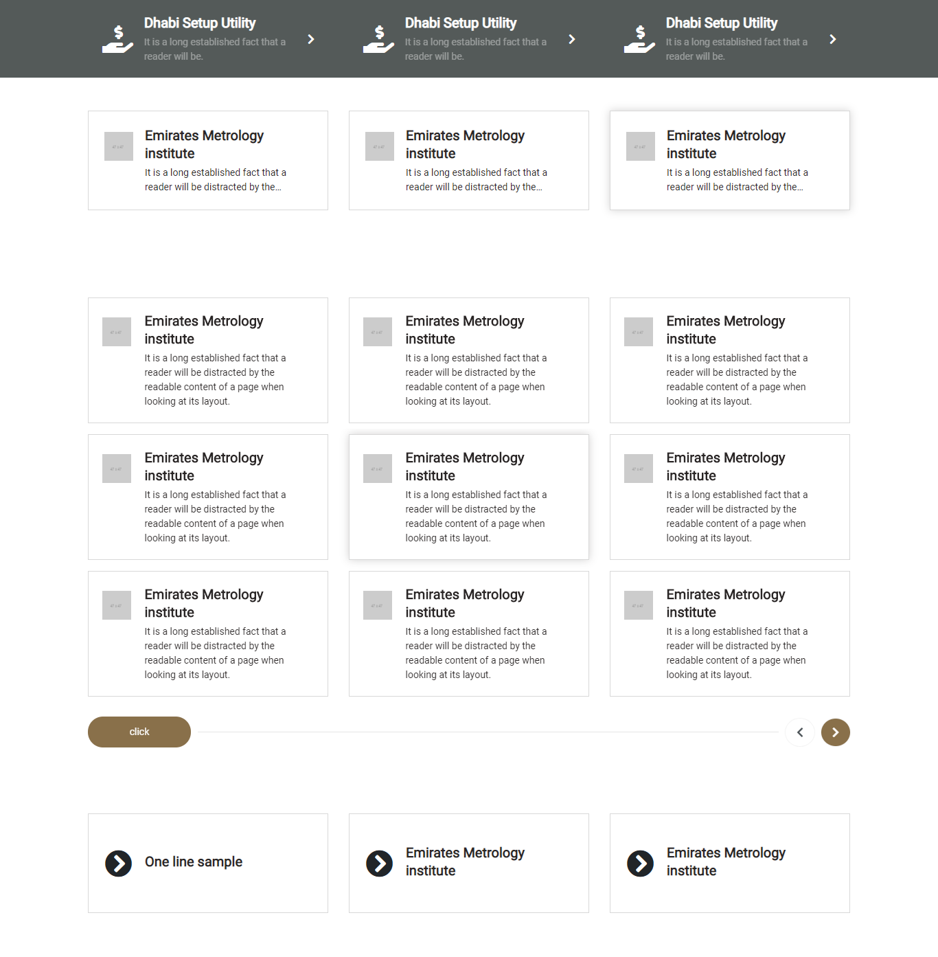

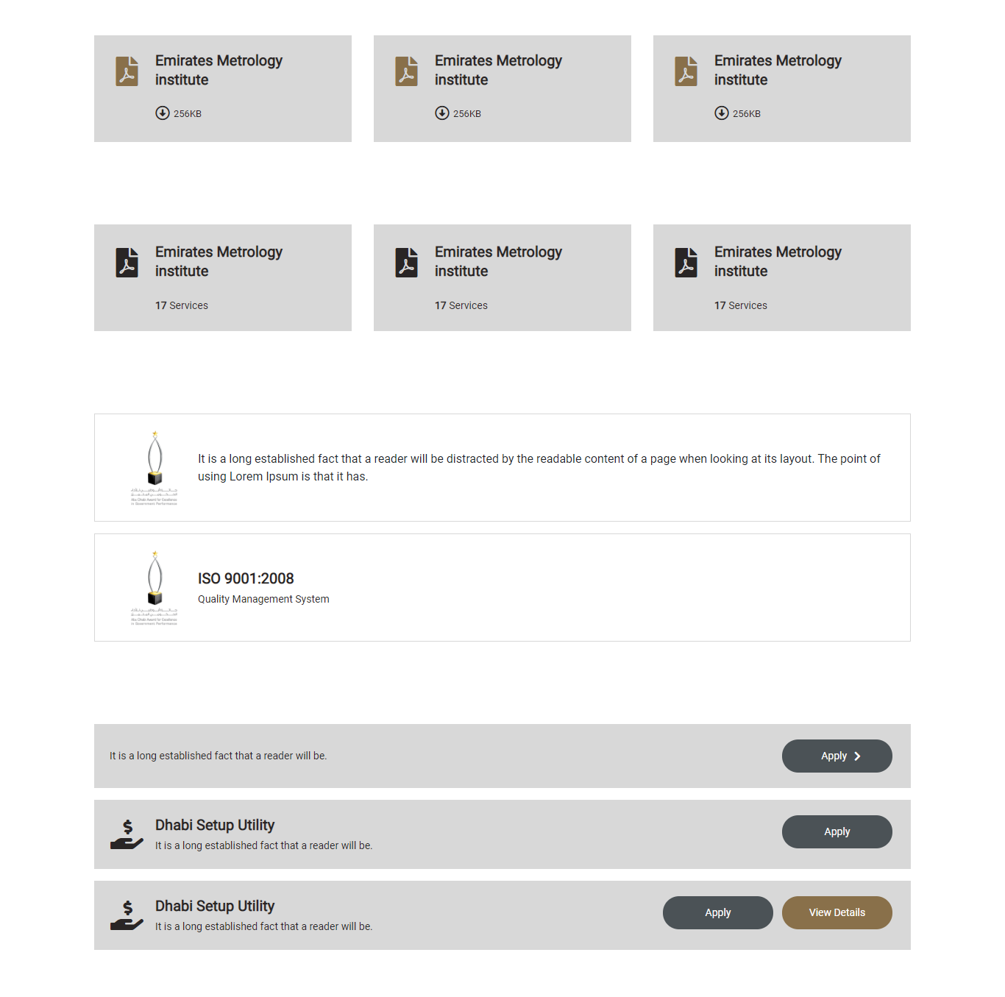

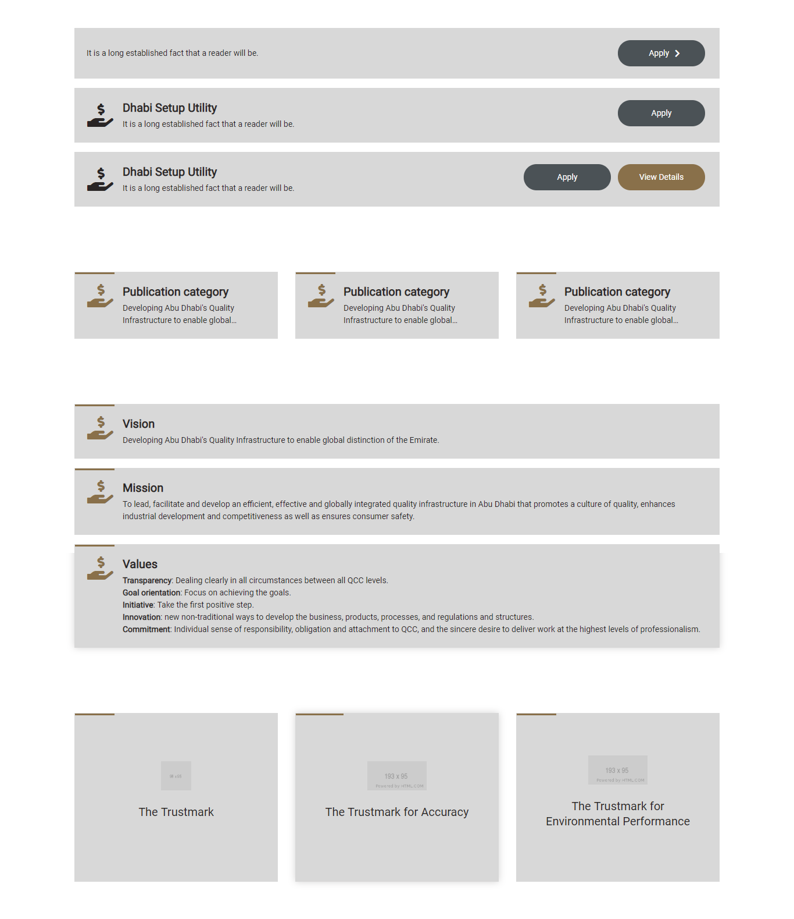

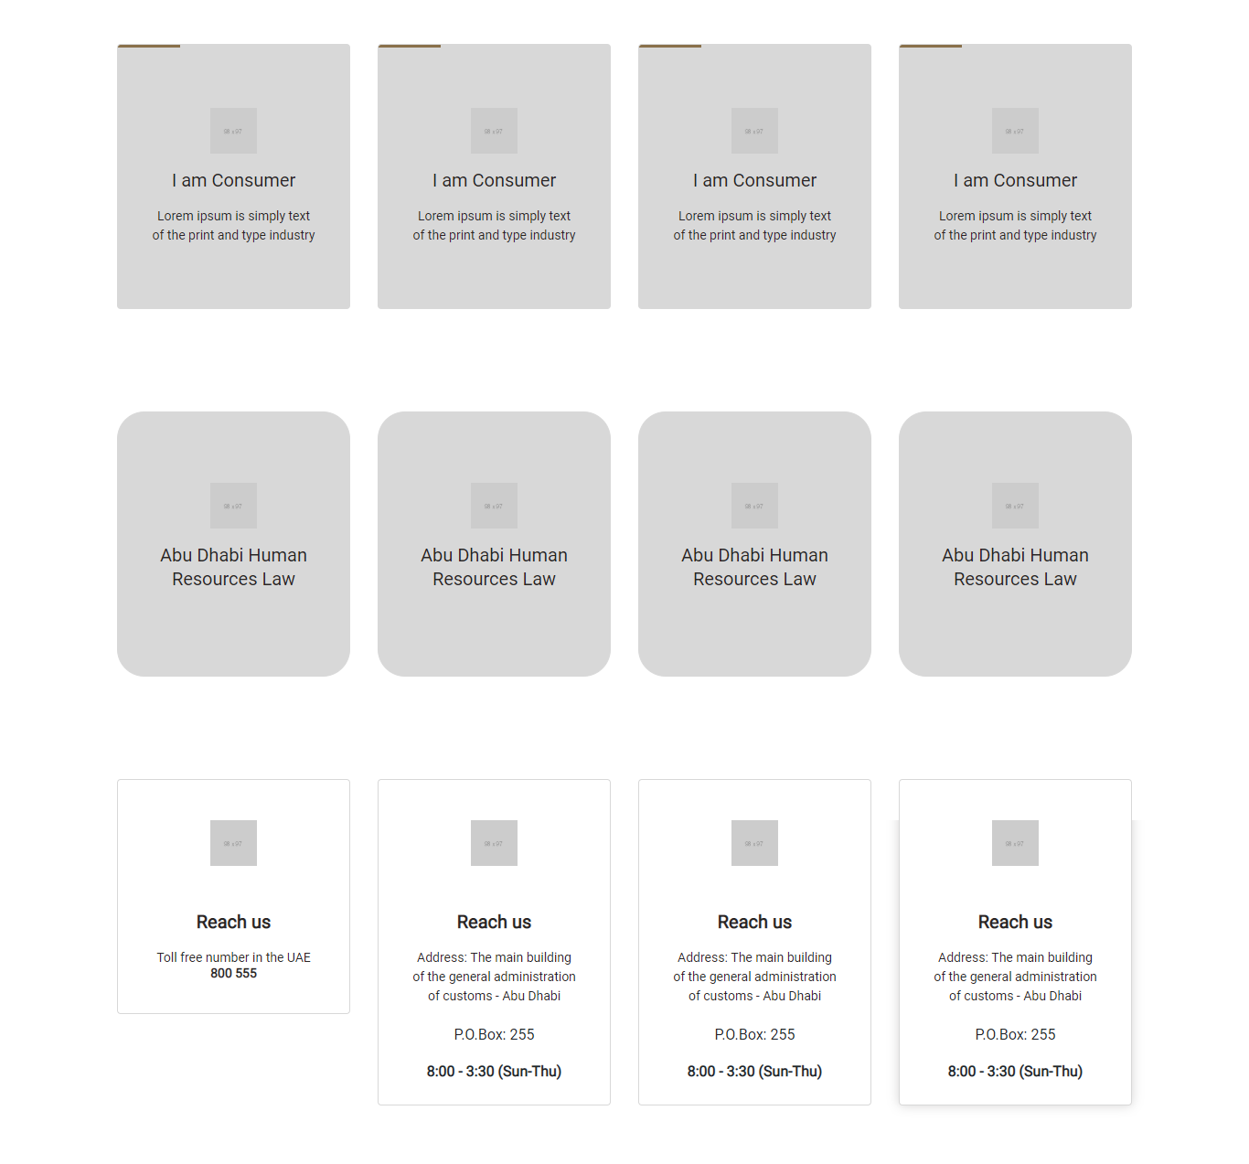

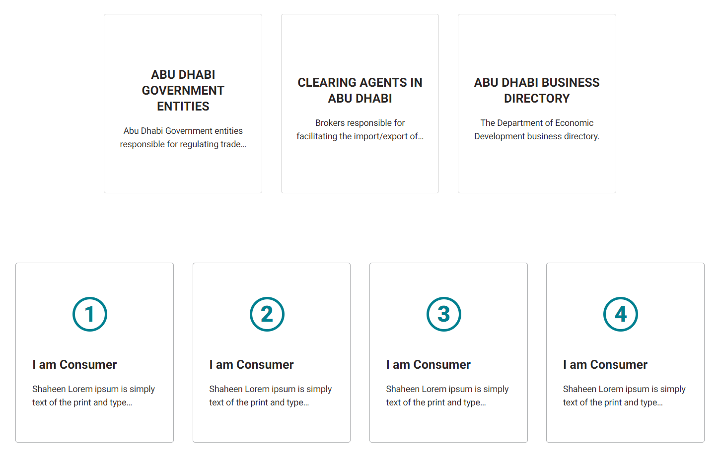

# How to use.

1. The available commands for this project .
   1. Compile : npm run gulp compile -- –path ex-icon-card –extension
   2. Compile & include under ADGE tenant : npm run gulp compile -- –path ex-icon-card –extension –full –dest [ADGEFolder]
   3. Deploy : npm run gulp deploy -- –path ex-icon-card –extension
2. *Now project have full copy from this extension theme under the project theme and you can apply the project brand guideline and configure component based on project needs.*

# Component features and configure.

You have access now to configure component with the below item.

$icon-card-max-height: 175px !default;

$icon-card-fixed-height: 175px !default;

$icon-card-min-height: 140px !default;

$icon-card-large-min-height: 290px !default;

$icon-card-larger-min-height: 370px !default;

$icon-card-medium-min-height: 250px !default;

$icon-card-height-md-screen: 140px !default;

$icon-card-title-lines: 2 !default;

$icon-card-bg-color: $white-color !default;

$icon-card-border-color: $grey-200 !default;

$icon-card-border-hover-color: $grey-900 !default;

$icon-card-border-size: 1px !default;

$icon-card-border-radius: 0px !default;

$icon-card-b4-bg-color: $grey-900 !default;

$icon-card-b4-height: 4px !default;

$icon-card-b4-width : 98px !default;

$icon-card-icon-color: $primary-color !default;

$icon-card-icon-color-secondary: $secondary-color5 !default;

$icon-card-title-color-secondary: $secondary-color5 !default;

$icon-card-title-color: $grey-900 !default;

$icon-card-title-fontsize: 22px !default;

$icon-card-description-fontsize: 14px !default;

$icon-card-description-lineheight: 22px !default;

$icon-card-description-color: $black-color !default;

$icon-card-link-color: $secondary-color5 !default;

$icon-card-link-font-size : 13px !default;

$icon-card-link-hover-color: $black-color !default;

$icon-card-alt-bg-color: $grey-100 !default;

$icon-card-alt-color: $black-color !default;

$icon-card-alt-bg-hover-color: $grey-900 !default;

$icon-card-alt-color-hover-color: $white-color !default;

$icon-card-hover-shadow: $black-color !default;

$icon-card-white-color: $white-color !default;

$icon-card-title-lineheight: 26px !default;

$icon-card-img-height: 50px !default;

$icon-card-tag-color: $grey-700 !default;

$icon-card-tag-icon-color : $grey-700 !default;

$icon-card-alt-border-color-hover: $black-color !default;

$icon-card-tag-font-size : 14px !default;

$icon-card-meta-link-font-size: 14px !default;

$icon-card-meta-link-font-weight : bold !default;

$icon-card-meta-link-icon-wh : 25px !default;

$icon-card-meta-link-after-bg:transparent;

*// Number Card*

$icon-card-numbercard-icon-padding: 10px !default;

$icon-card-numbercard-icon-circle-color: #008090 !default;

$icon-card-numbercard-icon-font-color: #008090 !default;

$icon-card-numbercard-icon-font-weight: 900 !default;

$icon-card-numbercard-icon-font-size: 36px !default;

$icon-card-numbercard-icon-wh: 45px !default;

$icon-card-numbercard-icon-border-color: $grey-300 !default;

*//Border hover effect*

$icon-card-hover-effect-boxshadow-bottom:10px;

$icon-card-hover-effect-boxshadow: 0px $icon-card-hover-effect-boxshadow-bottom 0px 0px $grey-900 !default;

$icon-card-hover-effect-transition: 0.2s !default;

$icon-card-hover-effect-translateY:-7px !default;

$icon-card-hover-effect-scale : 1.02 !default;

$icon-card-icon-margin-side:20px !default;

$icon-card-icon-font-size:40px !default;

$icon-card-icon-text-align:center !default;

$icon-card-icon-min-width:50px !default;

$icon-card-hover-effect-translateY:-7px !default;

# How to configure component.

There are various ways to configure the component:

1. **CSS Class Configuration (on the variant)**

These styles can be applied in the variant to get the desired result

|  |  |  |  |  |
| --- | --- | --- | --- | --- |
| **Feature** | | | **Modifier CSS class** | |
| Change min height for card to 290 | ex-icon-card--large | |
| Change min height for card to 250 | | | ex-icon-card--medium | |
| Add strip line colored with primary color | | | ex-icon-card--shortb4 | |
| Support hover effect on strip line | | | ex-icon-card--w-b4-hover | |
| Add vertical line colored | | | ex-icon-card--verticalb4 | |
| Add full width strip line | | | ex-icon-card--fullb4 | |
| Reset height and make it auto | | | ex-icon-card--reset-height | |
| Change the card color to be white by default | | | ex-icon-card--white | |
| Make the card bg to be transparent | | | ex-icon-card--transparent | |
| Remove card border | | | ex-icon-card--border-less | |
| Display card alternative view with alt colors | | | ex-icon-card--alt | |
| Allow hover on alternative card view | | | ex-icon-card--w-alt-hover | |
| Limit title to be fixed height , add this to card-title | | | truncate truncate-2 card-title—fixed-height | |
| Border hover effect | | | ex-icon-card--hover-effect | |
| Number Card | | | ex-icon-card--numbercard | |

1. **Adding Built-In or Bootstrap Class (on the variant)**
   1. Spaces, Font weights, Display, Position properties etc can be added by bootstrap classes
      1. i. Spacing: <https://getbootstrap.com/docs/4.0/utilities/spacing/>
      2. ii. Flex: <https://getbootstrap.com/docs/4.4/utilities/flex/>
      3. iii. Font: <https://getbootstrap.com/docs/4.0/content/typography/>
   2. These classes should only be added to match the design
   3. For built-in classes check 7 Below to see the entire list
2. **SCSS Variable Override (on the _override.scss file)**

To configure the component we can take the above variables from section **4. Component features and configure** and add them to: adge-ph2/themes/<ADGE>/vars/_override.scss, this file with your desired changes to match the design.

1. **Complete style override**
   1. This should be the last and final option if the above 3 didn’t get you the desired output
   2. This is overwriting the SCSS of the component by adding your own style to it
   3. **Note: Take permission before doing this override**
   4. Instructions:
      1. Open the file /adge-ph2/themes/<ADGE>/sass/overrides.scss and add your own SCSS styles to override the faulty component.

# Dependencies

components-icon-card.css

components-sxa-components.css

query-fancybox-min.js

owl-carousel-min.js

slick-min.js

fancybox-init.js

slick-init.js

truncate-init.js

# Examples

Examples1:

I need to change text color.

I’ll copy the below variables from extension theme.

$highlight-main-tittle-color: $primary-color;

Then will paste the above variable in project folder theme in file _override.scss and change with any variable based on site needs.

$highlight-main-tittle-color: $secondary-color;

Examples2:

I need to the button shape from square to had a rounded corner.  
I’ll copy the below variables from extension theme.

$button-shape-square: $border-radius-value;

$border-radius-value: 0px;

Then will paste the a above variable in project folder theme in file _override.scss and change with any variable based on site needs.

$button-shape-square: $border-radius-value;

$border-radius-value: 20px;